**Creating Microservices for account and loan**

**FOLDER STRUCTURE**

**ACCOUNT-MICROSERVICE**

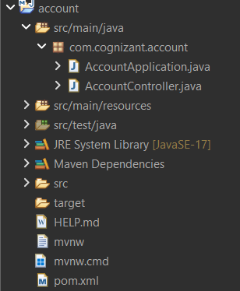

**AccountController.java**

package com.cognizant.account;

import org.springframework.web.bind.annotation.*;

*@RestController*

*@RequestMapping*("/accounts")

public class AccountController {

*@GetMapping*("/{number}")

public Account getAccount(*@PathVariable* String number) {

return new Account(number, "savings", 234343);

}

static class Account {

private String number;

private String type;

private double balance;

public Account(String number, String type, double balance) {

this.number = number;

this.type = type;

this.balance = balance;

}

public String getNumber() { return number; }

public String getType() { return type; }

public double getBalance() { return balance; }

}

}

**AccountApplication.java**

package com.cognizant.account;

import org.springframework.boot.SpringApplication;

import org.springframework.boot.autoconfigure.SpringBootApplication;

*@SpringBootApplication*

public class AccountApplication {

public static void main(String[] args) {

SpringApplication.*run*(AccountApplication.class, args);

}

}

**OUTPUT**

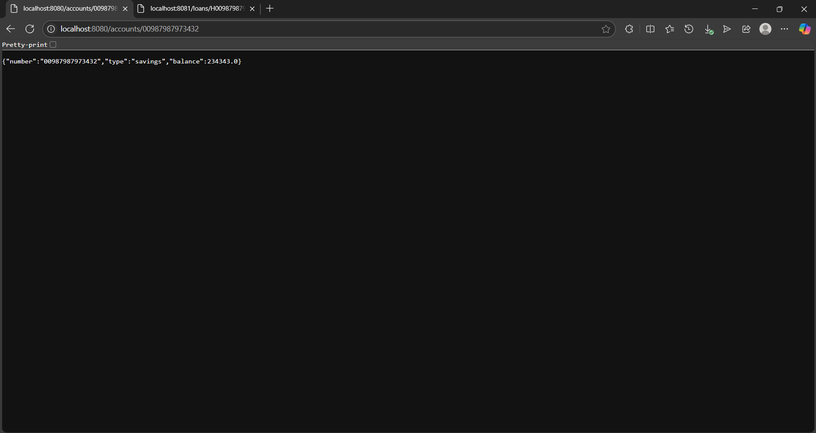

**LOAN MICROSERVICE**

**FOLDER STRUCTURE**

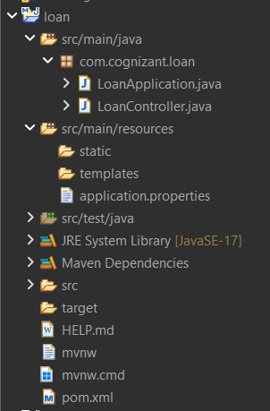

**LoanApplication.java**

package com.cognizant.loan;

import org.springframework.boot.SpringApplication;

import org.springframework.boot.autoconfigure.SpringBootApplication;

*@SpringBootApplication*

public class LoanApplication {

public static void main(String[] args) {

SpringApplication.*run*(LoanApplication.class, args);

}

}

**LoanController.java**

package com.cognizant.loan;

import org.springframework.web.bind.annotation.*;

*@RestController*

*@RequestMapping*("/loans")

public class LoanController {

*@GetMapping*("/{number}")

public Loan getLoan(*@PathVariable* String number) {

return new Loan(number, "car", 400000, 3258, 18);

}

static class Loan {

private String number;

private String type;

private double loan;

private int emi;

private int tenure;

public Loan(String number, String type, double loan, int emi, int tenure) {

this.number = number;

this.type = type;

this.loan = loan;

this.emi = emi;

this.tenure = tenure;

}

public String getNumber() { return number; }

public String getType() { return type; }

public double getLoan() { return loan; }

public int getEmi() { return emi; }

public int getTenure() { return tenure; }

}

}

**application.properties**

spring.application.name=loan

server.port=8081

**OUTPUT**

